TRAVEL SKETCHING ART TOUR WITH LEONIE NORTON
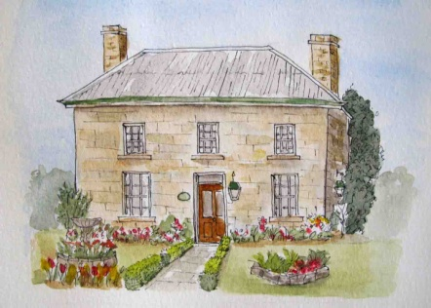
Oatlands House, Oatlands

TERMS & CONDITIONS

DEPOSIT PAYMENT: $300 AUD deposit required at the time of booking, along with the completed booking form. This can be paid by cheque, money or direct deposit.

PAYMENT OF BALANCE: 12 November 2015. This can be paid by cheque, money order or direct deposit.

TRAVEL INSURANCE: Travel insurance is recommended to cover any unforeseen events or illness which will force you to cancel your tour. Travel insurance may also include loss or damage to property or expenses incurred through changes in flights or hotel accommodation.

FITNESS LEVELS: This tour is not suitable for disabled or wheel chair bound people. An average level of fitness is required.

CANCELLATIONS: Notification must be advised in writing or email and the following cancellation charges apply.
-If cancellation is received prior to 12 November, the deposit only is forfeited, unless a replacement reservation can be substituted.
-If cancellation is made after 12 November (which would include the full amount having been already paid), the complete tour cost is forfeited, unless a replacement reservation is made.

COURSE CANCELLANTION OR AMENDMENTS: In the unlikely event the course may be cancelled, amended or changes made through unforeseen circumstances, alternative dates will be offered or full refunds will be made, as determined by Leonie Norton at her discretion. The deposit could also be transferred to another tour.

RESPONSIBILITY AND LIABILITY: No responsibility is taken for any loss or damage incurred during the period of the workshop, due to accident, illness or bodily injury, loss of your own equipment or that belonging to other parties or from any other cause. Missed connections or accommodation incurred through flight changes are your responsibility. If you must leave the course early or arrive later than the start date, travel and accommodation costs incurred are your own responsibility. No refunds apply.

PHOTO RELEASE: Permission is granted for photographs of my work and/or myself to be taken by Leonie Norton in conjunction to the Travel Sketching Workshop/Art Tour. Permission is granted for such photographs, with or without my name, and for any lawful purpose, including publicity, advertising and web content to be used.

BOOKING FORM: A signed Booking Form and your deposit is required to confirm your place on the tour. It is also an agreement to the acceptance of the Terms and Conditions. The person signing the booking form must be over 18 years old.

TRAVEL SKETCHING ART TOUR WITH LEONIE NORTON
Leonie Norton – 24/321 Edgecliff Road, Woollahra NSW 2025, Australia

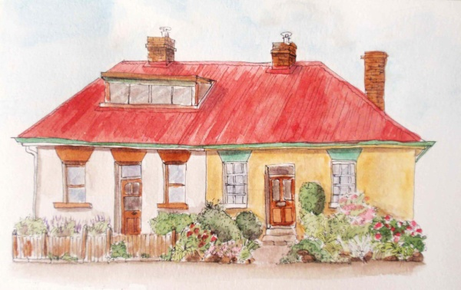
Barrack Point cottages

BOOKING FORM

Sketching Historic Tasmania. 30 January- 5 February 2016

Please complete, sign and mail or email the Booking Form to secure a place on the tour.

Your reservation will be confirmed once your deposit of $300 AUD per person has been received.

Use only one form per person. Participants must be over 18 years old.

Name:
Address:
Email:
Home Phone: Mobile:

Payment method:
Cheques or money orders to be made payable to Leonie Norton

Direct Deposit transfers:
ANZ Bank
BSB: 012 257
Account: 535119008

If transferring the money by internet banking, please use your name as Reference. If paying directly through a bank branch, please use your telephone number.

Acceptance of Terms and Conditions

Signature: ________________________________________________

Date: _______________________________________________

